Contents
- Overview of Grade Book
- Orientation to Grade Book pages
- Using Grade Book
  - Setting up your Grade Book
  - Creating Grade Categories
  - Grade Category Setting- Caution!
  - Moving Items
  - Adding Items
  - Adding Marks
  - Creating Final Marks
  - Giving Extra Credit

Overview of Grade Book
All the grades for each student in a course can be found in the course gradebook, or 'Grader report' in Administration > Course administration > Grades.
The grader report collects items that have been graded from the various parts of Moodle that are assessed, and allows you to view and change them as well as sort them out into categories and calculate totals in various ways.
When you add an assessed item in a Moodle course, the gradebook automatically creates space for the grades it will produce and also adds the grades themselves as they are generated, either by the system or by you.
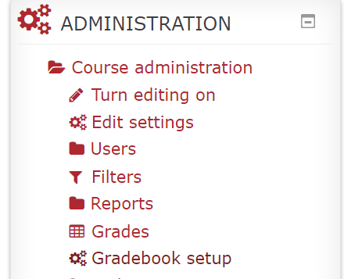
Orientation to Grade Book Pages (* Most frequently used Grade Book pages)
View
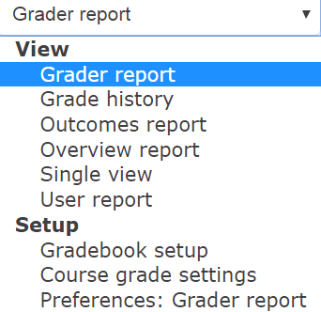
There are many different views or pages in Grade Book that support the variety of tasks you may want to do with the students’ grades: viewing a specific student’s course grades or a student’s grade for multiple courses, searching for specific assignment marks, overriding grades or creating categories and items to mirror the Grade Book to your course outline. The following outlines each of these pages and their main usage.

*Grader Report
This is the default page when you link to the Grade Book. You can enter or override grades when you turn editing on (top right corner). The grades are highlighted yellow to show that grades have been adjusted manually.
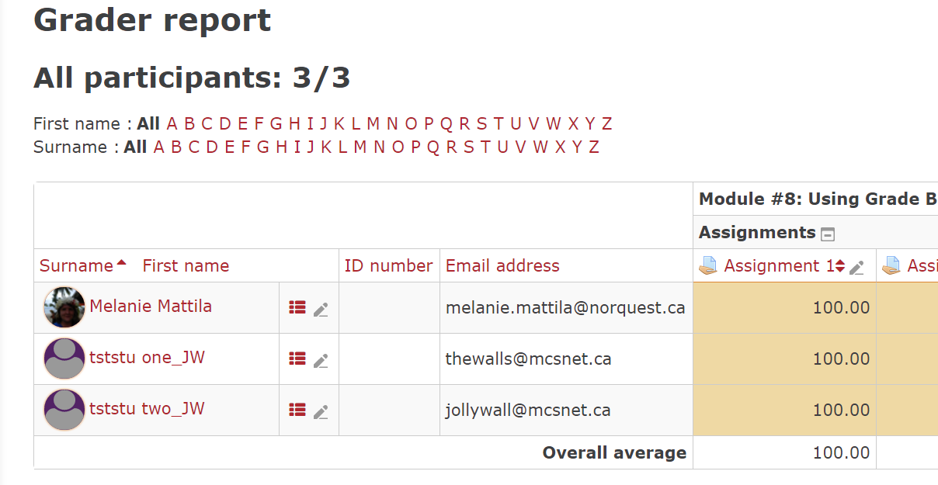

Grade History
On this page you may search out one student’s marks in a course or review all students’ marks in an assignment, etc. Of course, you can find this data in the User Report or the Grader Report. You can also look at revised grades only, but these are highlighted for you in the Grader Report. If you had multiple graders for your course, this could be a great tool to compare how graders assessed assignments.

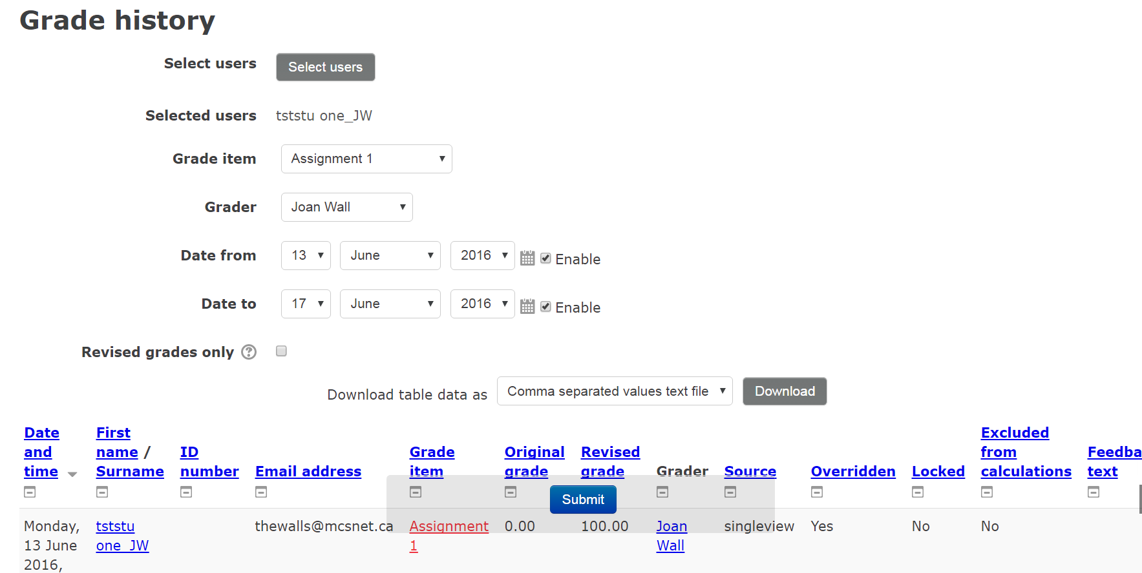

Outcomes Report
The outcomes report helps teachers monitor their students' progress using Outcomes, specific descriptions of what a student has demonstrated and understood at the completion of an activity or course. Each outcome is rated by some sort of scale.
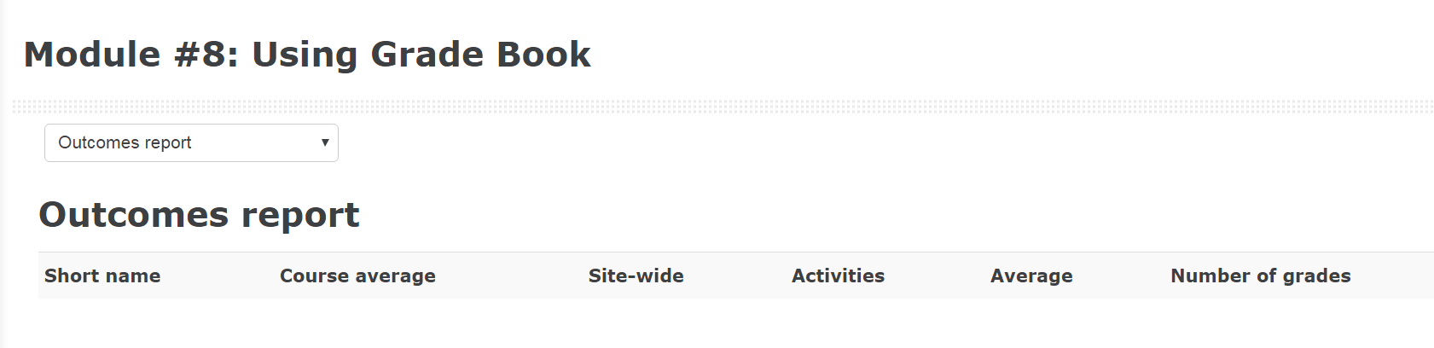

Overview report
This Moodle page reviews marks for selected students in courses you teach or are attached to in your teacher role. Remember, as faculty we should be keeping students’ grades confidential. This should be a consideration when adding people to your course to view.

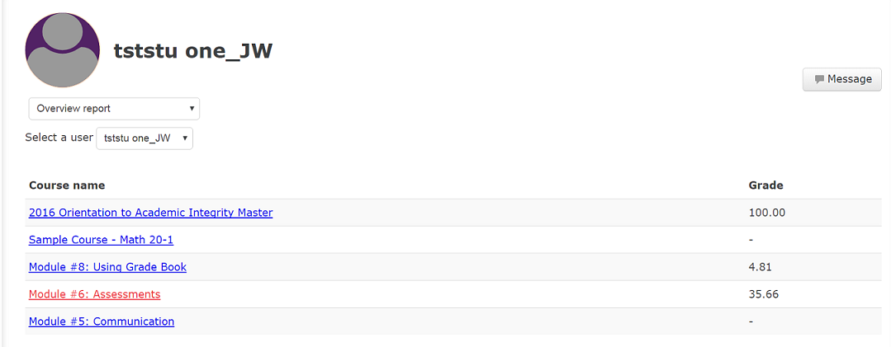

*Single View
Single view allows a course teacher to view either all the grades of one single student or a single grade item for all students. Grades may be excluded, or overridden and modified. It is also possible to bulk insert a grade, which might be useful, for example, if you wish to give the grade 0 to all students who did not submit work.
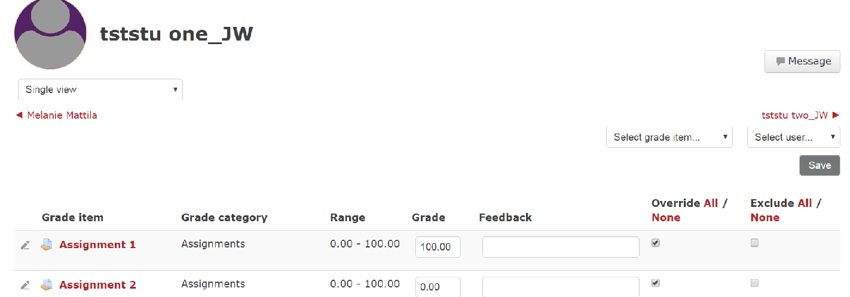

*User Report
The User Report is what the students view when they access Grade Book. There are many options to setting up the User Report. Once you get used to Grade book, you may want to experiment with the settings. Do you want the students to see their rank (how well they did compared to others in class) for each assignment? Generally, students see the breakdown of their marks and optional teacher comments.
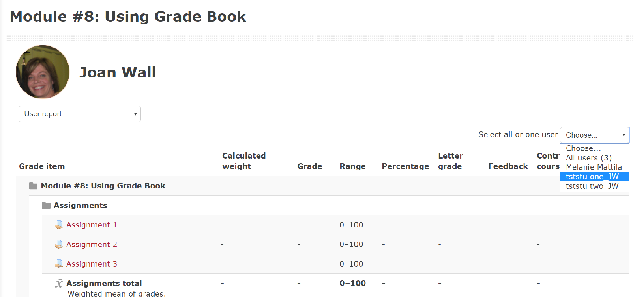

Set-up
*Grade Book Set-up
This is the first page in Grade Book you should view to set your Grade Book to match your Course Outline. On this page, one creates categories such as “Assignments, Tests, Participation Activities” and set weightings. Items that are not created automatically through Moodle Activities can be added. For instance, if you need an attendance mark or a participation mark, you may need to create these items.

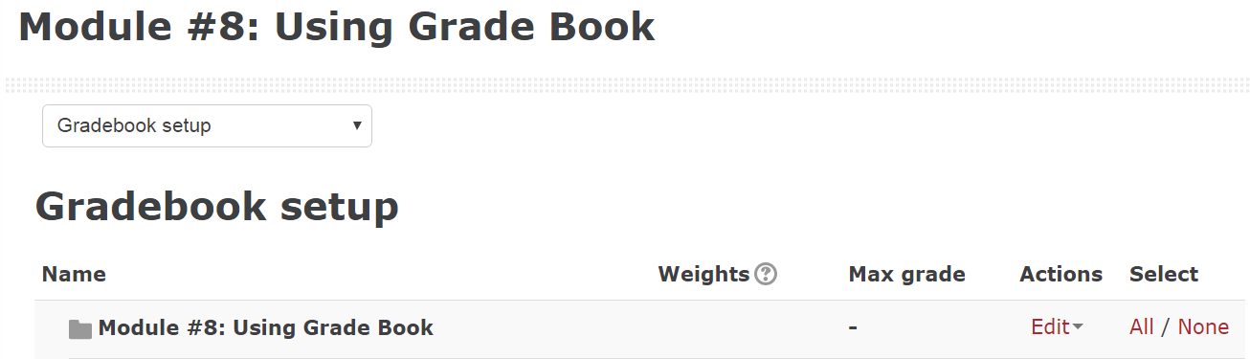

Course Grade Settings
Course settings determine how the gradebook appears for all participants in the course. Until you gain some proficiency in using Grade Book, it is recommended you leave the default settings.

Grader Report Preferences
This page determines how you will see the Grader Report, Grade Books landing page by default. Until you gain some proficiency in using Grade Book, it is recommended you leave the default settings.

Setting up your Gradebook
The first step is to set up your Grade Book. Your Grade Book should be structured to mirror your Course Outline.
First Step: Setting Categories
Your course outline reviews how the student is assessed. Most often, these marks are grouped into categories: Assignments, Mid-terms, Quizzes, Participation. Setting up categories makes the Grade Book easy for the students to follow.

Adding Categories in the Gradebook
Follow these steps to group your activities into different categories.

- Choose “Gradebook Setup” under the Administration block, or in the drop down menu when you are in Grade Book.
- Scroll all the way to the bottom of the screen.
- To add a category for the different Moodle activities, click on “Add category”

- Set up the Grade category (Aggregation, Value) and save
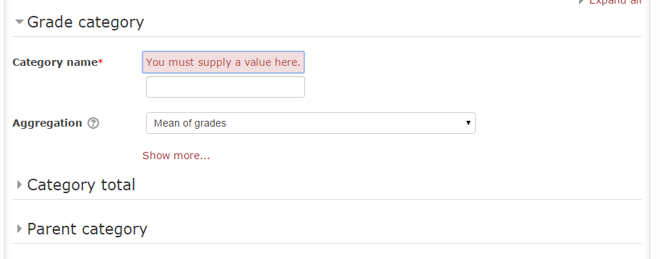

Grade Category Setting – CAUTION!
Aggregate Only Non-Empty Grades
In Moodle’s Gradebook, non-empty grades are items that have been assigned a mark for an individual student. Empty grades indicate where a student has missed a Gradebook entry (for instance, by not yet submitting an assignment or completing a quiz).
The “Aggregate Only Non-Empty Grades” option is turned on by default. This means empty grades are not included as part of the calculation.
The following table will show the difference achieved when ‘Aggregate Only Non-Empty Grades Turned On’ is selected:
 | Assignment (30%) | Midterm (30%) | Final (40%) | Course Total
With Aggregate Only Non-Empty Grades Turned On | 75 | 65 | Empty (will ignore in calculations) | 70
Aggregate Non-Empty Grades Turned Off | 75 | 65 | Empty (will treat as a zero) | 42

From the example above, you can see that the two options can have a significant impact on a student’s final mark. Alternatively, you may also choose to put a zero in the Final column so the column would not be empty. (This is similar to how marks must be entered in PeopleSoft.)
To adjust the setting, follow these steps:
1. In the Settings block, under ‘Course Administration’, click on Grade Book Setup, or select in the dropdown menu within Grade Book.
2. For the course Category, select the Edit> Edit Settings.
3. Press on Show More.
4. Ensure the box is checked for Exclude Empty Grades.
Expand all
Grade category
Exclude empty grades
Show less...

5. Scroll down and click Save changes.

Moving items into a category
The best practice is to have your Grade Book categories set up before entering assignments and quizzes. When you are editing the assignment/quiz settings you can choose what category this activity is in under the section Grades. If you have not done this, items will appear in Grade Book in the order that you have created them. It will be necessary to move the assignments/quizzes to the appropriate categories.
Steps:
1. Add the Assignments to the new Assignments category by clicking on the Move button. 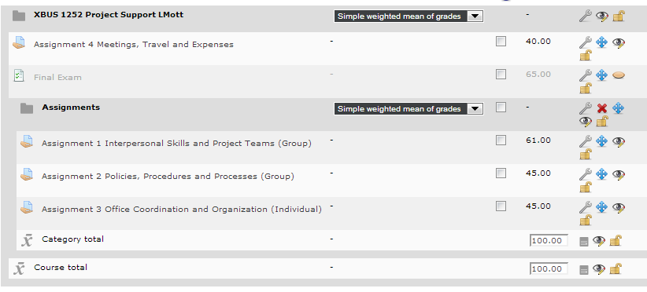
2. A new page will appear. Choose the box that reflects the appropriate location.
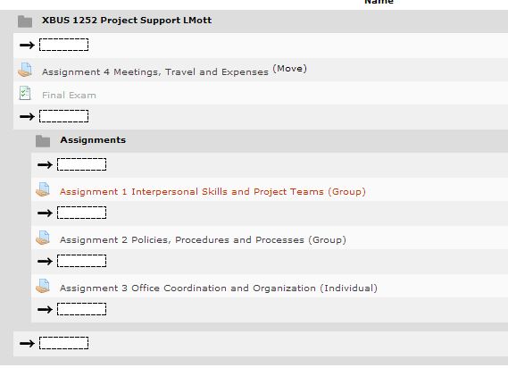
3. Click Save.

Creating New Items
Not all assignments will be completed within Moodle.
Examples:
- Students went on a field trip and were given five marks for attending.
- Students participated in Guided Practice or CIA Exams.

Follow these steps to allocate a mark for an assignment that was completed outside Moodle.

- Choose “Grade Book Setup” under the Course Administration or from the dropdown menu within Grade Book.
- Scroll all the way to the bottom of the screen.
- To add a grade item to the Gradebook, click on Add grade item.
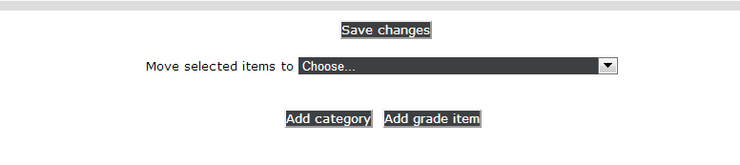
4. Enter an appropriate name for the new column. You can also select the grade type (eg. value or scale), change the maximum or minimum grade, hide the item from student view, and lock the item so that grades cannot be changed.
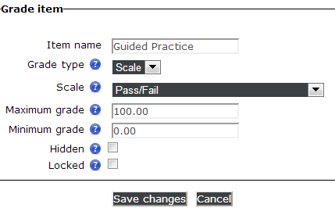

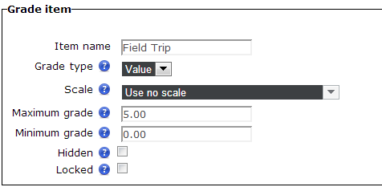

5. Select the Grade Category

6. Save the changes.
Note: The ‘Locked’ feature is useful if there are several instructors in a course with editing privileges. One instructor can enter the grades and ‘lock’ them so other instructors cannot edit the grades afterwards. If you select the ‘Locked’ feature before students have completed the activity, any grades you enter will not be counted when overall grades are calculated, as Moodle will disregard any changes for that grade item. It is best to leave this option unselected until after the grades have been entered or overall grades will be calculated incorrectly.

Adding Marks
Most marks should be entered by clicking on the assessment tool (assignment or quiz), or they will be entered automatically.
For example, you can mark an assignment by clicking on the assignment and then choosing View/grade, all submissions. Under the Grade column, click on the pencil to edit an individual student mark. For each individual assignment, you can add a mark, comments, and a feedback file.
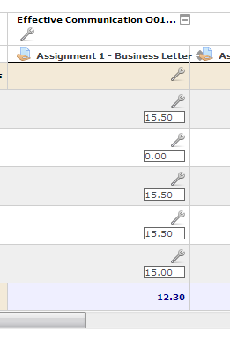
On occasion, you may need to manually override marks or enter a column of marks for an assignment that was done outside Moodle.
Examples:
- A student did not participate in a group assignment and therefore will earn a lower mark than the rest of the group.
- Students need a participation mark for an activity conducted outside Moodle, such as a participation mark for a field trip.

If you need to change a mark for a student:
- Go to the Gradebook by selecting ‘Grades’ underneath ‘Course administration’ in the Settings block.
- Select Turn editing on. (top right)
- Make changes as necessary to the student marks.
- Click on Update at the bottom of the gradebook.

Creating Final Marks
Before you calculate final marks, it is important to understand the different aggregation methods used by Moodle for calculated marks. See next pages.
Aggregation Method | Description | Example
Mean of grades | Each graded item is first converted to a percentage. The overall grade is then a simple average of these percentage values. Each item (regardless of how many points it is worth) has the same weight. | Quiz 1 is out of 5.  Quiz 2 is out of 10.  Quiz 3 is out of 20.  With “mean of grades,” each quiz makes up the same amount (1/3 of the student’s grade).
Simple weighted mean of grades | Similar to “Weighted mean of grades,” with the difference that the weight for each grade item is determined by its maximum (e.g., a 100-point assignment has a weight of 100, an 8-point assignment has a weight of 8.) The score for each grade item is multiplied by its total point value. The resultant values are then added together and divided by the total point sum of all grade items. | Quiz 1 is out of 10.  Quiz 2 is out of 20.  With “simple weighted mean,” the more points an activity is “out of,” the more it affects the grade. In this case, Quiz 2 will affect the grade twice as much as Quiz 1.
Weighted mean of grades | Each grade item is assigned a weight and this weight is used to determine the importance of each item in the overall mean. The score for each grade item is multiplied by its corresponding weight. The resultant values for each grade item are then added together and divided by the sum of all weights. | Quiz 1 is out of 10.  Quiz 2 is out of 20.  With “weighted mean,” the above numbers do not matter: you decide the weight of each item yourself. Maximum control!
Median of grades | The overall grade is the middle grade (or the mean of the two middle grades) when the grades are normalized and arranged in numeric order. | With “median,” only one grade matters: the “middle of the pack” grade. All the others are ignored. (If there are two middle grades, Moodle will “split the difference.”)
Lowest grade | The overall grade is the lowest grade, after normalization. | The worst grade is kept, the others ignored. (You might use this in a firearms safety course, or a parachute packing course, where one substandard performance can fail a student.)
Highest grade | The overall grade is the highest grade, after normalization. | The best grade is kept, the others ignored. (Use this to encourage review and persistent practice.)
Mode of grades | The overall grade is the grade that occurs most frequently after normalization. | The grade you got most often is kept. (Gets the student’s “most typical” performance. Not recommended unless the range of grades is quite narrow.)
Sum of grades | The scores for all grade items are added together and the result is divided by the sum of maximums for all grade items. When the “sum of grades” is used, a grade item can act as extra credit for the category. This means that the grade item’s maximum grade will not be added to the category total’s maximum grade, but the item’s grade will. | Sum of grades calculates a “running total” rather than an average.  Quiz 1 is out of 10  Quiz 2 is out of 10  Quiz 3 is out of 10  Bonus quiz is out of 10  If the student gets 4 out of 10 on the first quiz, 6 out of 10 on the second quiz, and 8 out of ten on quiz 3, they have 18 marks out of 30 points, or 60%. If the student got 7 out of 10 on the bonus quiz, then 7 more marks will be added to their total, but not the maximum grade for the quiz. In this case, the student would have 25 total marks, but the category is still out of 30 marks. The score for the student would be 25/30 points, or 83%.
.

Aggregation Method Calculations

Calculating using Mean of Grades
If each assessment has an equal weighting and you just require an average, use “mean of grades.”
Example:
Assign 1 – 33.3%
Assign 2 – 33.3%
Assign 3 – 33.3%
1. Under Grade Book Setup, click on Edit Settings and choose Mean of grades.
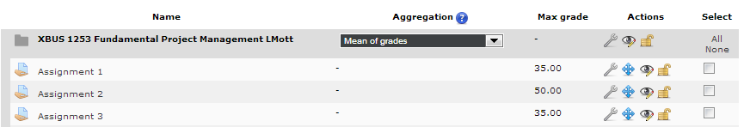

2. Click the ‘Save Changes’ button when done assigning aggregations or making other changes to the Gradebook.

Calculating using Weighted Grades
If each assessment item in your course has a different weight, follow these steps:
Example:
Assign 1 – 20%
Assign 2 – 30%
Assign 3 – 20%
Final Exam – 30%
1. Under Grade Book Setup, click on Edit Settings and choose Weighted mean of grades.
2. Beside each item, enter in the appropriate weight.
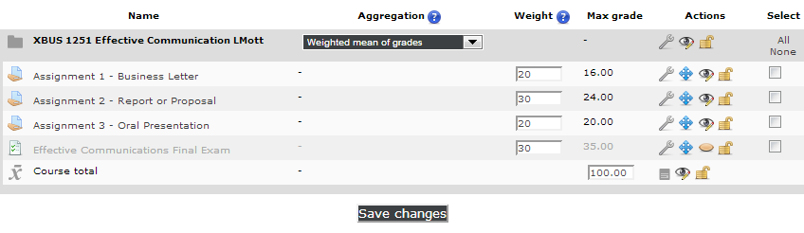
3. Click the ‘Save Changes’ button when done assigning aggregations or making other changes to the Gradebook.

How to Give Extra Credit

In the gradebook, click the Setup tab.
Locate the item to be marked extra credit. Under the Actions column in that row, click Edit Settings.
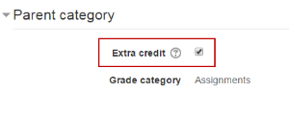
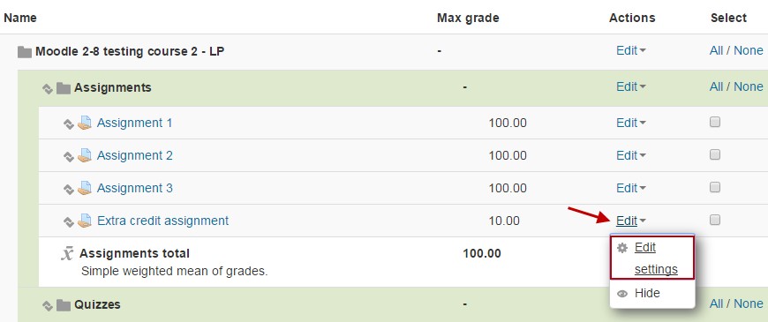

Check the Extra credit checkbox.
ALERT!
The Extra credit option is NOT available when using the following aggregations:
a. Weighted mean of grades
b. Mean of grades

Save changes
The extra credit item will now have a + to the right of the Max Grade. The + symbol indicates that it is extra credit.
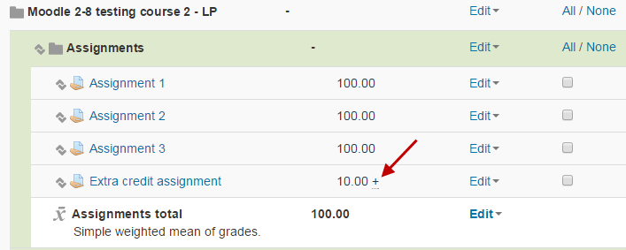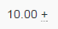
For additional information see Moodle Docs Gradebook or contact Moodle Help.

